**AIM:** Design Christmas dual led chaser lights.

**APPARATUS:** Arduino, LED’s, Resistance 470 ohm, wires, Breadboard.

**CIRCUIT DIAGRAM:**

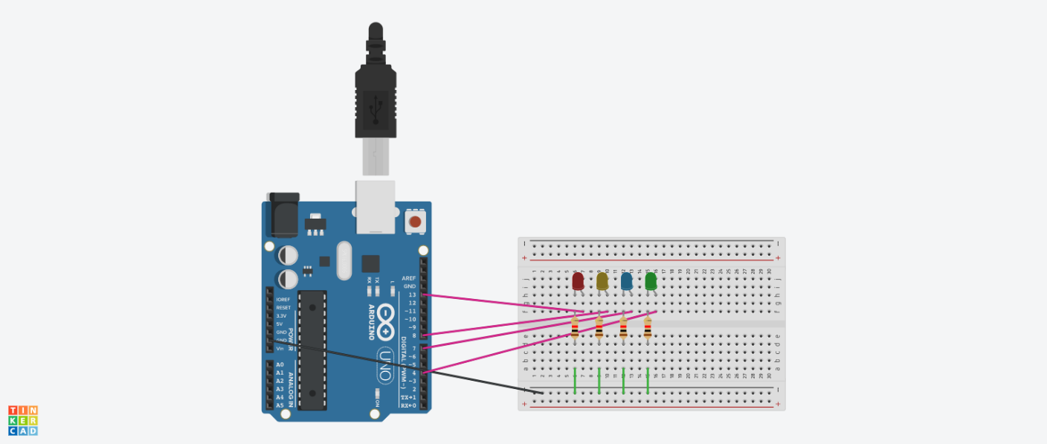

**THEORY:**

Arduino is an open source electronics platform based on easy to use hardware and software. Arduino boards are able to read inputs light on a sensor, a finger on a button, or a Twitter message and turn it into an output activating a motor, turning on an LED, publishing something on line.

**OBSERVATIONS:**

When the circuit get completed, the light starts blinking in the LEDs.

**PRECAUTIONS:**

* Connections must be neat and tight.
* The n-type of LED is to be connected to the ground properly.
* The code must be entered correctly.